# *Development Project I (420-E50-HR)*

# *Assignment 1 – PEA Framework*

Date assigned: Thursday, August 24, 2017

Date due: **Part A: Thursday, August 24, 2017, 2:50 p.m.**

**Part B: Thursday, August 31, 2017, 11:00 a.m.**

**Part C: Monday, September 11, 2017, 8:00 a.m.**

**Late assignments will not be accepted.**

**Learning Objectives**

Upon successful completion of this assignment, the student will be able to:

Computer Science Student Setup

* Set up course folders.
* Set up Outlook on the desktop.
* Enter a timetable in Outlook.
* Like the Computer Science Facebook page

PEA objectives

* Describe the requirements for the digital portfolio that is developed for the Computer Science Program Exit Assessment (PEA)
* Develop a layout for the digital portfolio
* Set up the navigation for the digital portfolio
* Create the pages based on a template or master page
* Select an appropriate colour scheme for a digital portfolio
* Develop a banner for a digital portfolio
* Create an external style sheet for the digital portfolio
* Incorporate feedback to make improvements to the digital portfolio

To do:

This assignment involves creating a digital portfolio (or web site) for the Computer Science Program Exit Assessment (PEA).

# Part A – Computer Science Setup

## **Microsoft® Outlook Set Up**

1. Start Microsoft Outlook 2016 by selecting **Start, Programs, Microsoft Office, Microsoft Office Outlook 2016** or using the icon in the task bar or desktop. The Outlook Startup window will open. Click Next.
2. The next window asks you to confirm that you want to set up an account. Make sure the Yes option is highlighted and click Next.  
     
   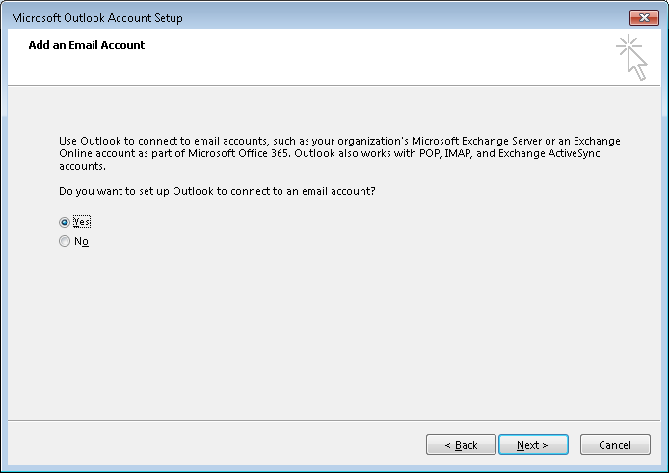
3. The Add New Email Account screen is displayed. Your name and email address should be filled in by default. If your name is not automatically filled in, add your email address in the Email address field. Your email address is lastname.firstname@cegep-heritage.qc.ca.

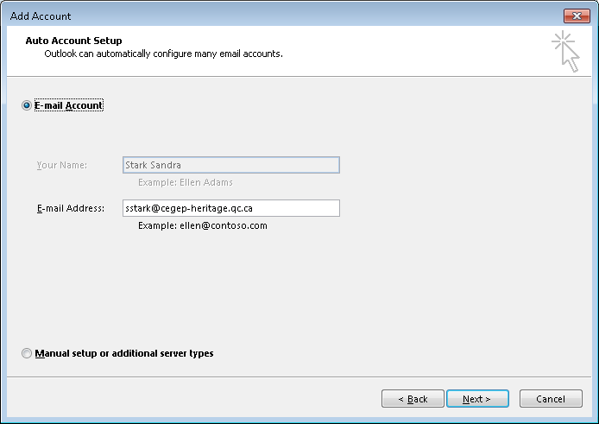

1. Click **Next**. Your email account should be successfully set up now:

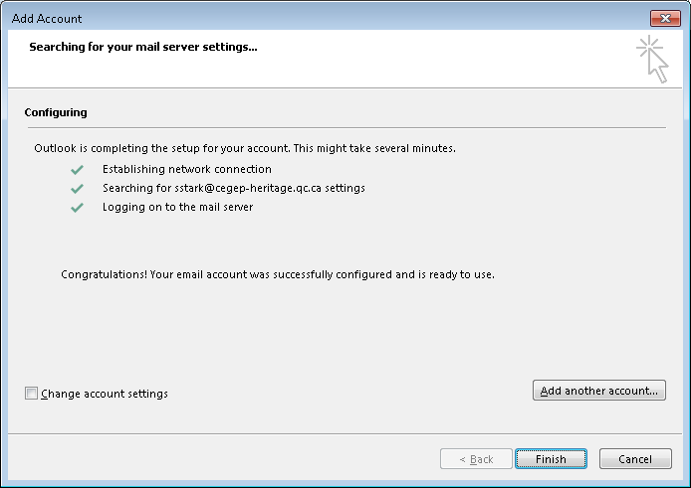

**If you do NOT receive the above screen, let me know immediately. Do NOT click finish. We may have to set up your account manually.**

1. Click **Finish**. Outlook 2016 will now open.

***Note***: You have set up your profile on the desktop computer. The next time you use this computer, simply open Outlook and select your profile.   
  
If you use another computer, you will have to repeat this procedure to set up your profile there.

### **Calendar Set Up**

1. If it is not already started, start Microsoft® Outlook 2016 by selecting Start, Programs, Microsoft Office, Microsoft Office Outlook 2016 or using the icon in the task bar or desktop.
2. Select **Calendar** at the bottom of the screen and change the view to be **Week** by selecting the tab below the tool bar.
3. Set up your timetable by repeating the following steps for each course block in your timetable.
   1. Starting with Thursday, August 24, select a block of time that corresponds to the course and then select **New Appointment** on the shortcut menu.
   2. Select the **Recurrence** option and ensure that the Appointment Recurrence is set up as follows:
      1. The Start and End time should be the starting hour and ending hour for the block in your timetable. The end time should not be changed to be 10 minutes before the hour. The Duration is automatically calculated.
      2. The Recurrence pattern should be weekly, and the appropriate day should be checked.
      3. Set the **Range of recurrence** to **End after: 15** occurrences, for courses on Tuesday or Wednesday and **16** for courses on Monday, Thursday or Friday. Click **OK**.
   3. In the **Subject** box, type the name of the course.
   4. In the **Location** box, enter the room number.
   5. In the top ribbon bar, set the Reminder (the bell icon) for the entry to be None.
   6. Click **Save and Close**.
4. Change your Outlook calendar to match the academic calendar as follows:
   1. Delete the occurrences on Labour Day (September 4) by selecting all the blocks on that day, selecting Delete from the shortcut menu, and ensuring that **Delete this occurrence** is selected.
   2. Delete the occurrences on the Thursday after Thanksgiving (October 12) by selecting all the blocks on that day, selecting Delete from the shortcut menu, and ensuring that **Delete occurrence** is selected.

Move the occurrences from Thanksgiving Monday (October 9) to the Thursday after Thanksgiving (October 12) by double clicking the appointment and changing the date. Make sure that Open this occurrence is selected. You can also drag and drop the occurrence to the new day, in which case you will be prompted to confirm that you are changing only the occurrence. Select Yes.

Delete the occurrences on Friday November 3 (Study day), by selecting all the blocks on that day, selecting Delete from the shortcut menu, and ensuring that **Delete occurrence** is selected.

Mark Monday December 11 as “Last day of Formal Classes”, indicate this is free time so that it doesn’t block off your calendar, but is visible.

Mark Wednesday, December 13 to Thusday, December 21 as “Examination Period”, indicate this is free time so that it doesn’t block off your calendar, but is visible.

While viewing your calendar click on the ShareCalendar button on the menu bar.

Share your calendar with the user **#Teaching Staff Computer Sciences** (all the Computer Science teachers). Under Details, select “Full Details”

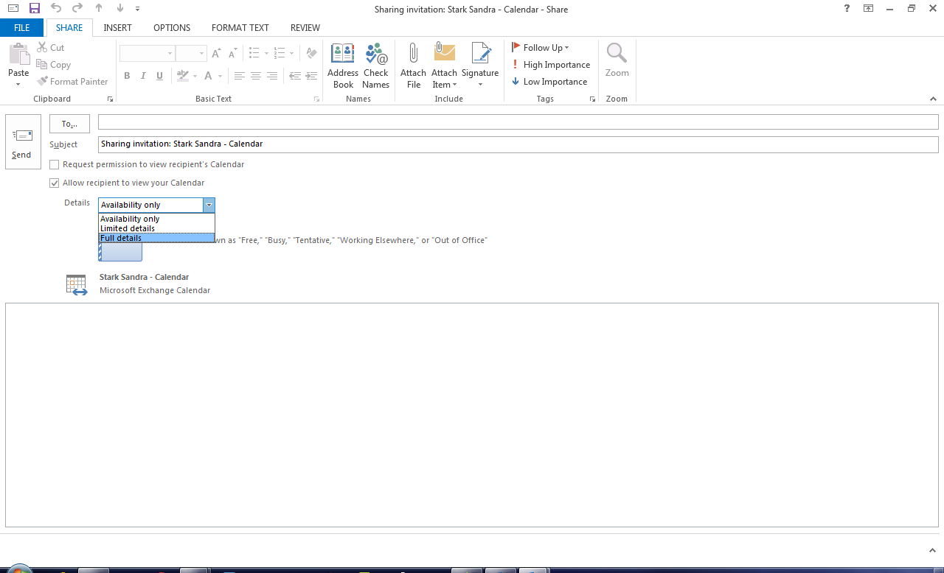

Click **Send**.  
This will allow teachers to view your calendar.

## **Set up Course Folders**

Double-click on the My Computer icon at the upper left hand corner of the desktop. This opens Windows Explorer for the computer and network drives accessible to you.

Double-click on the H: drive icon (*your_username*). This is your home drive. It is also where My Documents will take you.

Select File🡪 New 🡪 Folder from the menu bar.

Replace the words New Folder with 420-E50.

Double-click on 420-E50. Create two new folders here – call one Labs and the other one Assignments.

Repeat steps 3 – 5 for your other computer science 3rd year course.

## **Facebook, Pizza Lunch, Kristen Roy Award**

If you have not already done so in the past, login to Facebook, find the Heritage College Computer Science page and like the page. This will keep you informed of department information and activities.

You should have an Outlook invitation for our first Computer Science pizza lunch of the year. Please accept the invitation if you intend to attend (which you should).

Check your College e-mail. You have an e-mail message from Sandra regarding the Kristen Roy award, a Computer Science award which several of you qualify for. If you qualify, put a note on your to-do list to apply for the award.

Check your College e-mail. You have an e-mail message from Sandra regarding your mentor. By default, you will be assigned the same teacher as a mentor that you had last year. If you would prefer a different teacher to be your mentor, please respond to the email from Sandra indicating your preferred mentor.

Ensure that you have Kahoot! and Socrative installed on your mobile device. You will need these apps in 3rd year.

## **Almost done setup …**

Update the “Completed” column below to indicate which tasks you have completed. I will mark this in-class.

|  |  |
| --- | --- |
| Task | Completed (Y/N) |
| Outlook Application setup | N |
| Outlook Calendar Set up and shared | N |
| Course Folders (H: drive setup) | N |
| Facebook (like) | N |
| Pizza Lunch meeting acceptance | N |
| Kristen Roy email processed | N |
| Mentor selection | N |
| Kahoot! Installed | N |
| Socrative Installed | N |
| This table updated correctly | N |

# Part B – Initial Version of PEA Web Site

See the Moodle page for this course for background information on the PEA.

1. Decide what tool will be used to create the web site.
2. Using the selected tool, develop a template, including the following items, for the web site:

* a banner area
* a navigation bar (the items in the navigation bar will be added later)
* a content area
* a copyright notice at the bottom of the page, similar to the following, with the appropriate links (your Heritage email address, a link to the Computer Science web site, and a link to the college web site):   
  © [Your Name](mailto:somebody@cegep-heritage.qc.ca), [Computer Science](http://www.cegep-heritage.qc.ca/Programs/Computer_Science/index.php), [Cegep Heritage College](http://www.cegep-heritage.qc.ca/), 2017. All Rights Reserved.

1. Using the template, create a page for each of the required portfolio contents, which are listed in the PEA document on the course page in Moodle. Each page should have a title and should contain a heading with the name.
2. Create the navigation area, based on the pages that were created in the previous step. Organize the menu items and name each link with an appropriate 1-2 word name.
3. Include a varying number of paragraphs of *lorem ipsum* text on several of the pages as a placeholder. For example, include one paragraph on one page and many paragraphs on another. This content will be used to gauge how the site behaves with different sized pages.
4. Include a link in the *lorem ipsum* text on the home page to illustrate how the link will be displayed.
5. Add your co-op report(s) to the site and include a link to them on the Applied Experience page.
6. Choose a colour palette of 3-5 colours, appropriate for the purpose of the web site and the intended audience, to be used on your web site.
7. Find or create an appropriate image to be used as the logo in the banner. Create a banner for the web site, using your colour palette, at least 2 different text sizes and the logo, and containing the following:

* name of the college,
* name of the program,
* your name,
* “Program Exit Assessment” title
* the year

1. Create a favicon based on the logo.
2. Use CSS to apply the colour palette and an appropriate font to the elements in the layout using the external style sheet. Use at least one of the new features in CSS3, such as: rounded corners, multi background images, multi-column, border images, or animation. Ensure that there are no inline styles.
3. Ensure that the site is responsive at the 768px, 992px and 1200px breakpoints. One way to accomplish this is to use a responsive CSS framework such as Bootstrap.
4. Create a text file named **ReadMe** in the PEA folder. Add the following to the file:

* Your name
* Rationale for the choice of colours in the colour palette
* Rationale for the design of the banner
* List of the CSS3 features used and how they were used
* The tools that were used to create the site, including any frameworks or sites that were used as a resource or reference. Include the tool used to create the logo.

1. Create a folder in your O drive named **YourUserName_E50_A01_PEA.** Deploy the site to the csdev server by copying the files and folders to the new folder and ensuring that the home page is in the root folder. Test the site using the following url: **http://csdev.cegep-heritage.qc.ca /Students/YourUserName/YourUserName_E50_A01_PEA/YourHomePage**

# Part C – Final Version of PEA Web Site

1. Present your site to the class for feedback.
2. Make the changes recommended by the class. The assignment will be marked based on the requirements for the site and on incorporating the feedback from the class.

**To submit**

When you have completed the assignment, create a zip file of the folder, name it **YourUserName_E50_A01_PEA**, and upload it to the Moodle page for this course. Your solutions MUST be portable (i.e. don’t fully hardcode URL paths, this should work after I unzip it and run it from an arbitrary file location).